AXC: Conform to the trend of the times and to be a pioneer in the development of the industry

On January 2, 2019, Ali Baba DAMO Academy issued a blockbuster of "DAMO 's Top Ten Trends in Science and Technology in 2019", and the blockchain is high on the list!
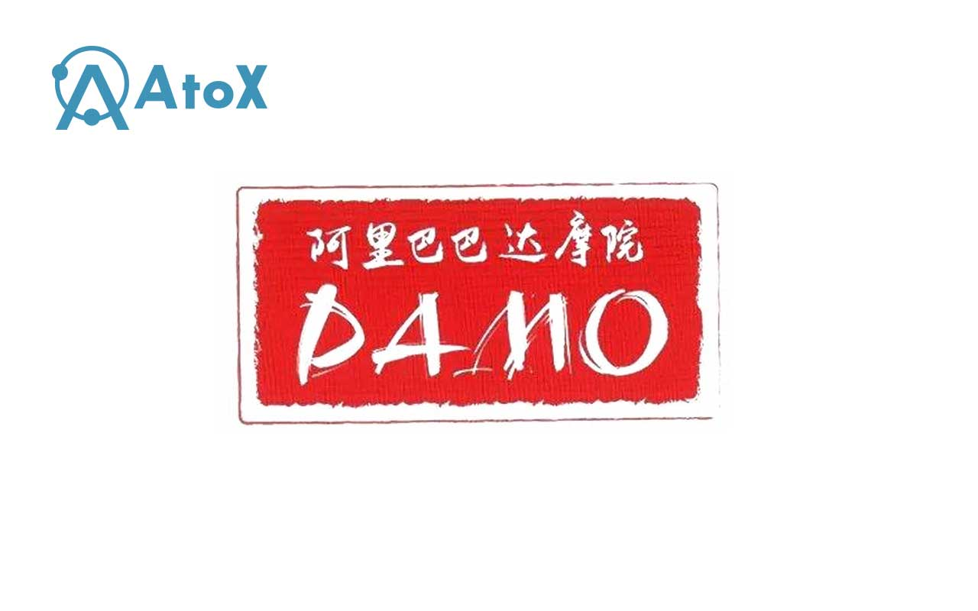

The development of science and technology has never stopped its pace, the information revolution, the mobile Internet revolution has not yet ended, and the intelligent revolution has come to us. The top 10 trends in science and technology in 2019 released by DAMO Academy include: urban real-time simulation is possible, smart city is born; voice AI passes Turing test in specific areas; AI-specific chips will challenge the absolute dominance of GPU; Large-scale graph neural network system will give the machine common sense; the computing architecture will be reconstructed; the 5G network will give birth to new application scenarios; the digital identity will become the second ID card; the automatic driving will enter a calm development period; the blockchain will return to rationality, and the commercial application will accelerate; Data security protection technology will emerge rapidly.
Let's take a look at its predictions for the new year’s blockchain:
Blockchain returns to rationality, and the commercial application is accelerating: In the digital process of various industries, IoT technology will support the trusted mapping of the world off the chain and the data on the chain, and the blockchain technology will promote the reorganization and optimization of trusted data on the circulation path, thus improving the efficiency of circulation and collaboration.
In many scenarios, such as cross-border remittances, supply chain finance, electronic bills and judicial letters, blockchain will begin to integrate into our daily lives. With the value of “link”, hierarchical architecture and cross-chain interconnection will become the technical foundation of blockchain’s scale. The blockchain field will return to rationality from excessive fanaticism and excessive pessimism, and commercial applications are expected to accelerate the landing.

In the past year, the fluctuation of the coin market have made people frightened and dare not to act rashly. But the development of blockchain technology is gratifying. This development trend has driven the people in the coin circle to shift their attention from the coin price to the technology. It has also prompted more and more R&D personnel to focus on technology improvement and application, which is a substantial improvement for the blockchain industry.

The emergence of AXC conforms to the trend of the times. The R & D team behind AXC comes from the most intelligent Jewish nation. AXC Silicon Valley Lab, relying on the strong technology and talent strength of world-renowned universities, focuses on overseas layout, implements a “distributed” office mode, and there is an international team, members come from Switzerland, North America, the Middle East, Europe and other places. At the same time, AXC Silicon Valley Lab is a high-quality project team that actually does something and engages in technology. It has an endorsement with sovereign credibility of government and eliminates air coins and fake projects.

It is on the basis of such a powerful strength that the AXC’s landing application based on blockchain 4.0 technology can be smoothly carried out. At this time, the AXC’s landing project, AtoX Swap has entered the end-of-development testing stage. After the official launch, users can use Swap for the operation of token storage, payment and other operations.

In addition, AXC recently entered into a deep strategic cooperation with Newbuy, the world's first cross-border e-commerce provider that supports the token trading, and started the first stop of ecological construction.

In 2019, AXC will respond to the call of the times and be the forerunner of industry development!
www.atox.io

